EVALUACIÓN DE INGLÉS
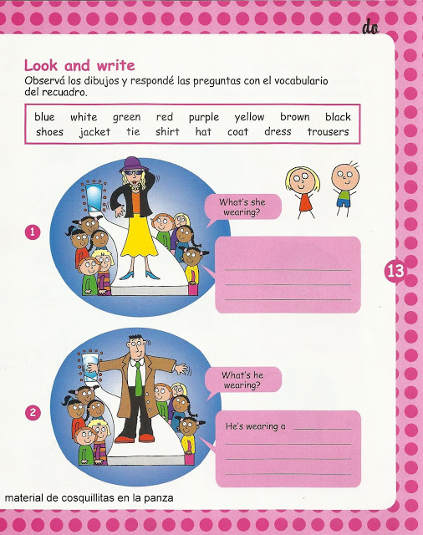
Name_________________________________
4

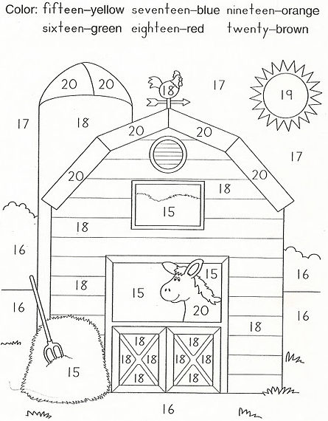
1
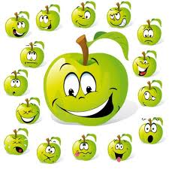
2. How many apples are there?
- One
- Six
- Sixteen
- Three
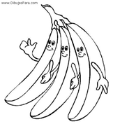
3. How many bananas are there?
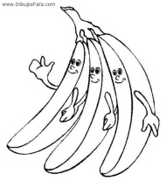
- One
- Twoo
- Three
- Nine

5. Draw
*He is a police officer

She is a nurse

